CDI58 Unigraphics Tutorials

 3

CAST Online Library Version: NX 3

Design
- An Overview of NX 1 hour
- NX Essentials 7 hours
- Sketcher 3 hours
- Feature Modeling Techniques 6 hours
- Additional Feature Modeling Techniques 5 hours
- Practice Projects 2 hours

Drafting
- Drafting Fundamentals 8 hours
Assemblies
- Assembly Modeling 8 hours

Total minimum 40 hours
Click on 

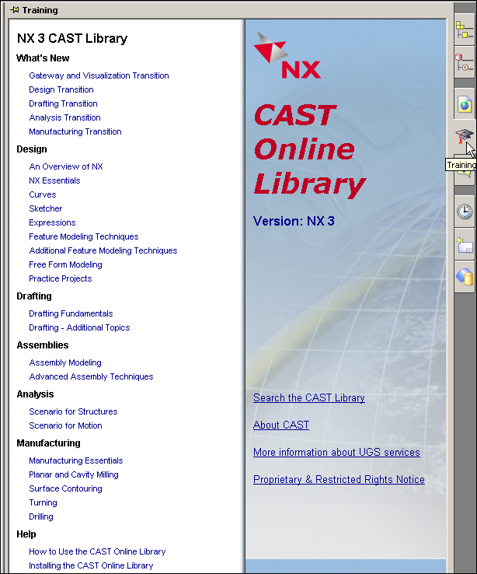
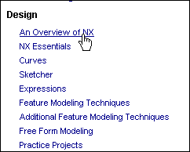

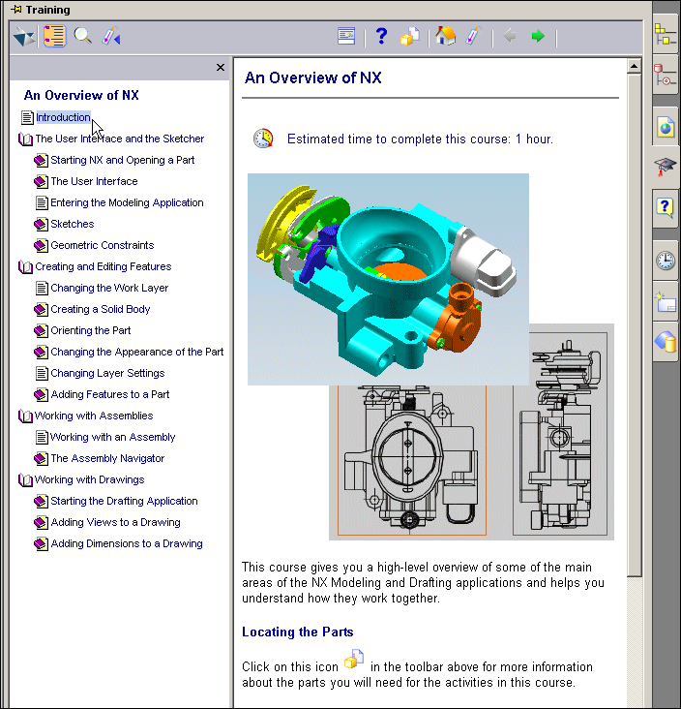

An Overview of NX

Estimated time to complete this course: 1 hour.

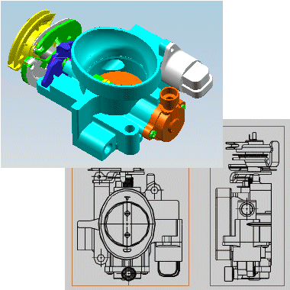

NX Essentials

Estimated time to complete this course: 7 - 10 hours.

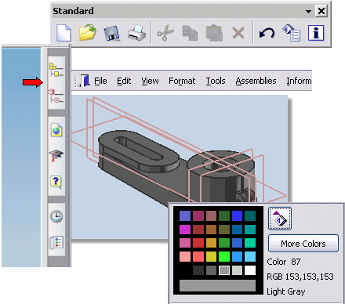

Sketcher

Estimated time to complete this course: 3 - 5 hours.

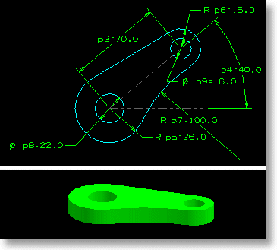
This course will show you how to create sketches, create sketch geometry, and constrain two dimensional line/curve geometry. You can extrude, revolve, or sweep the sketch geometry to build a model. You can also use sketches for defining sections, guides and cross curves for free form features.

Feature Modeling Techniques

Estimated time to complete this course: 6 - 12 hours.

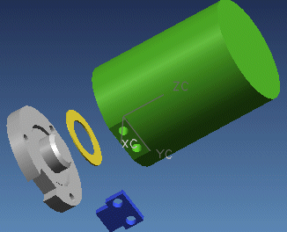
This course covers creating and editing techniques for basic modeling features and operations.

Feature Modeling Techniques

Estimated time to complete this course: 6 - 12 hours.

This course covers creating and editing techniques for basic modeling features and operations.

Additional Feature Modeling Techniques

Estimated time to complete this course: 5 - 10 hours.

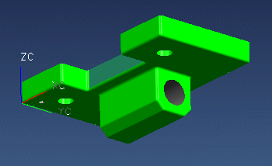
This course will familiarize you with additional feature creation techniques in the Modeling application.

Practice Projects

Estimated time to complete this course: 2 - 3 hours.

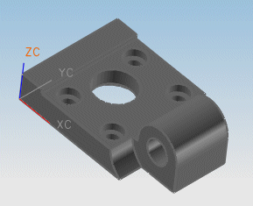
This is a series of five projects that will let you apply many of the skills you have learned in the basic courses.

Assembly Modeling

Estimated time to complete this course: 8 - 15 hours.

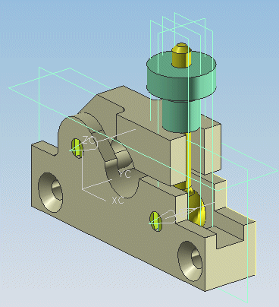
This course familiarizes you with some fundamental concepts and functions for working with assemblies.

Drafting Fundamentals

Estimated time to complete this course: 8 - 16 hours.

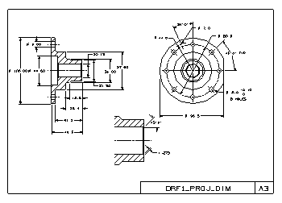
The Drafting application lets you create drawings with views of the part, dimensions, and necessary drafting annotations.

